Activity On Containers:

1. Deplyoing the containers in the lab environment using the student workstation.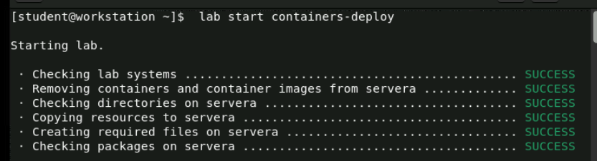
2. Log in to the servera machine as the student user.

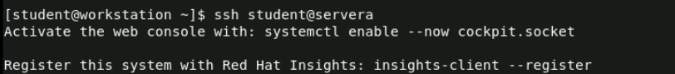

1. Installing all the container-tools . and setting the passwd as “student”.

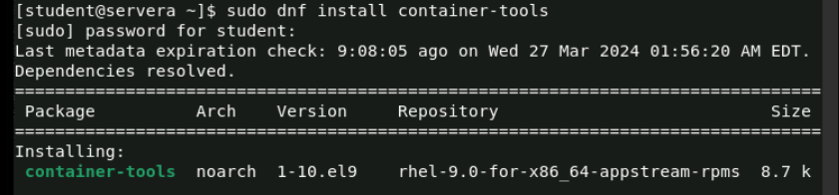

4.Making the directory for the regirstry (in this regisrty only have the containers images , so we are logging into that particular one.)

5.After creating the directory then entering creating the file and in that file location of the registry and insecure etc… should be given .

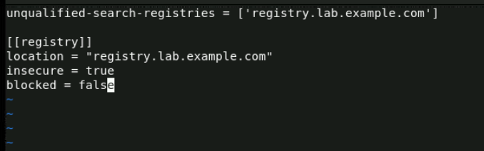

6.Verifying the command called podman info in which that file content is added or not in the classroom registry.

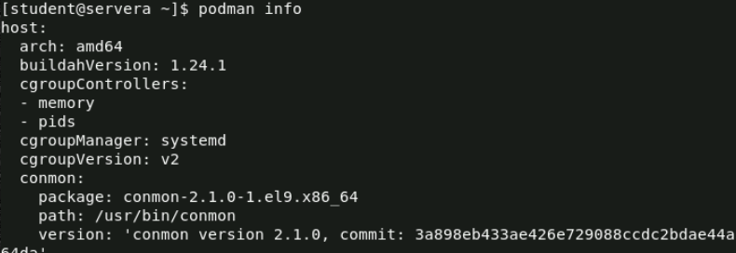

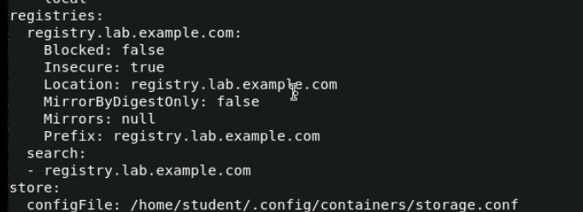

7. Login into the classroom registry for run and execute the containers with that registry only we can run and pull or remove the particular container so we login into to that particular one. And give the username as “admin” and passwd for that is “redhat321”.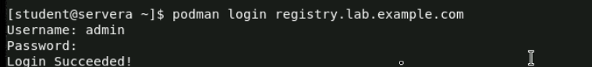

8.Serching a python-38 container in the registry.lab.example.com

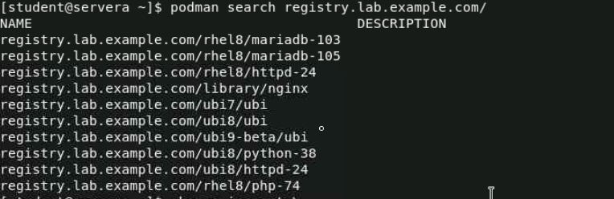



9.Inspecting the image .

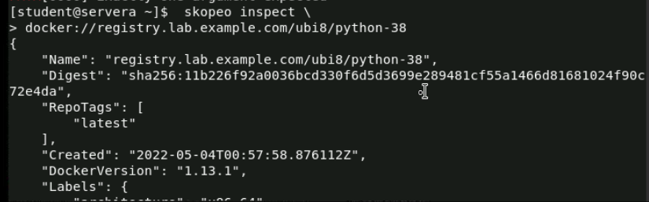

10.Pulling the pyton-38 container image into the registry.

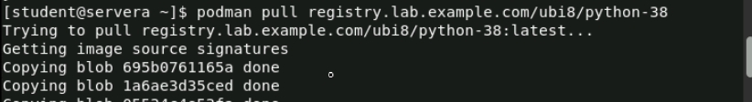

11. verfying the containers is downloadded to image repostry.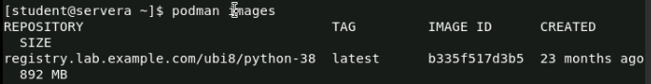

12. running the python38 container by usinfg podman run.

13.verfying that container is added or not .

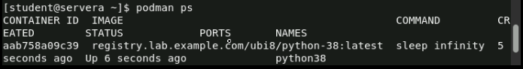

14. Build a container image called python39:1.0 from a container file, and use the image to create a container called python39.

Examine the container file in the /home/student/python39 directory.

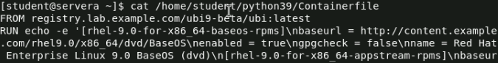

15. creating the conatiner image for that container file.

16. inspecting the container(python39).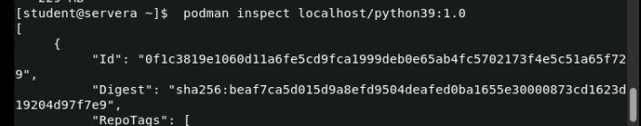

17. creating the python39 container.

18.starting the python 39 container.



19.Viewing the container if it is already running or not.

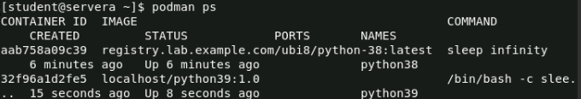

20.Moving the student scripts into a temporary scripts of python38 and python39.



21.And that executing each and every running container with a exec command. And after that checking the script was running or not.

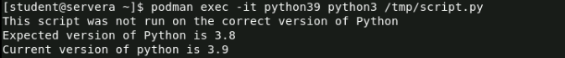



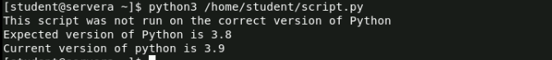

22.And after execting if we want to stop that particular container then we can stop it by usijng “podman stop <container_name>”.

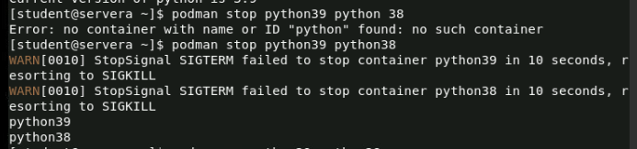

23.And after the stopping we can remove it .



**24.Reemoving the both pyhton38 and python 39 images in the registry .**

**podman rmi localhost/python39:1.0 \**

**registry.lab.example.com/ubi8/python-38:latest \**

**registry.lab.example.com/ubi9-beta/ubi**